This is a sample of the resources Legato Strategic Consulting provides through dedicated support to institutions like yours.
Using Cohorts in Workday Student Instead of Pending Completion Status

Why Move Away from Pending Completion Status
The Apply for Program Completion business process in Workday sets the Primary Program of Study Status to “Pending Completion.” This status can be overly restrictive, locking records and limiting flexibility. Students often change plans until the last minute, making it difficult to manage when records are prematurely locked. Cohorts provide a more flexible, reportable, and scalable way to manage graduation tracking.
Note: Screenshots for this guide are taken from work done at Legato customers

STEP 1: Collect Graduation Intent Via An External Form
- Create a form for students to indicate intent to graduate.
- Acceptable tools include Microsoft Forms, Slate Forms, Formstack, or similar platforms.
- Do not use Workday Questionnaires, as they are difficult to update and extract from.
Form data to capture should include:
- Intended graduation term or date
- Diploma name
- Diploma address
- Commencement attendance plans
- Hometown (if needed for ceremonies or publications)

STEP 2: Import Graduation Date into Workday
- Use EIBs (Enterprise Interface Builder) to bring form data into Workday.
- Import the following through EIBs:
  - Expected completion dates
  - Diploma name
  - Diploma address
  - Custom fields such as hometown, if needed
This allows student records to stay accurate without forcing the Pending Completion status.

STEP 3: Create Graduation Cohorts
- Set up a Graduation Cohort Collection in Workday.
- Include cohorts such as:
  - Applied for Graduation
  - Commencement Attendance
  - Commencement Term (for example, Fall 2025, Spring 2026)
  - Outreach Needed (students missing requirements or at risk)
  - Approved for Graduation
Cohorts can be combined into collections, providing flexibility and clear organization.

STEP 4: Build Reports and Dashboards
- Develop graduation dashboards and reports that pull from cohort data.
- Reports should cover areas such as:
  - Diploma orders
  - Students ready to graduate
  - Commencement lists
  - Outreach for unmet requirements
Because cohorts are visible on student records, staff can immediately see graduation intent and status.
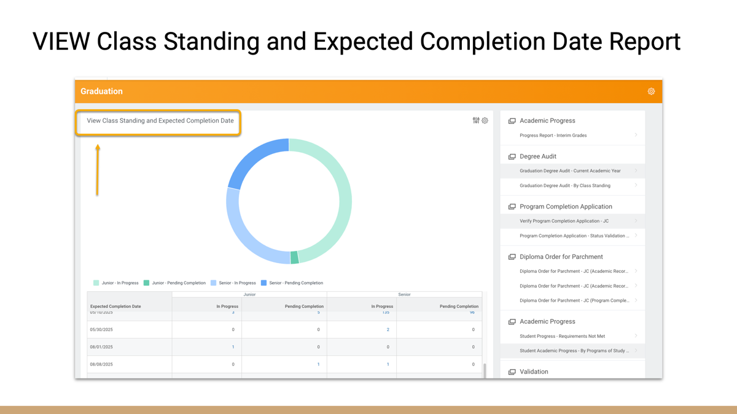
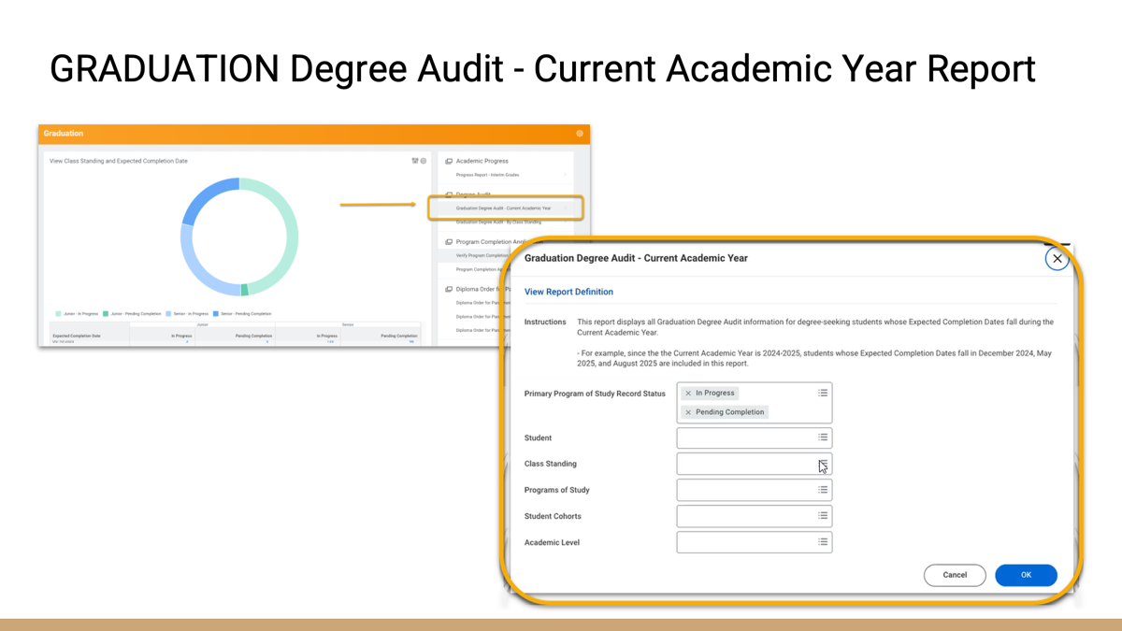
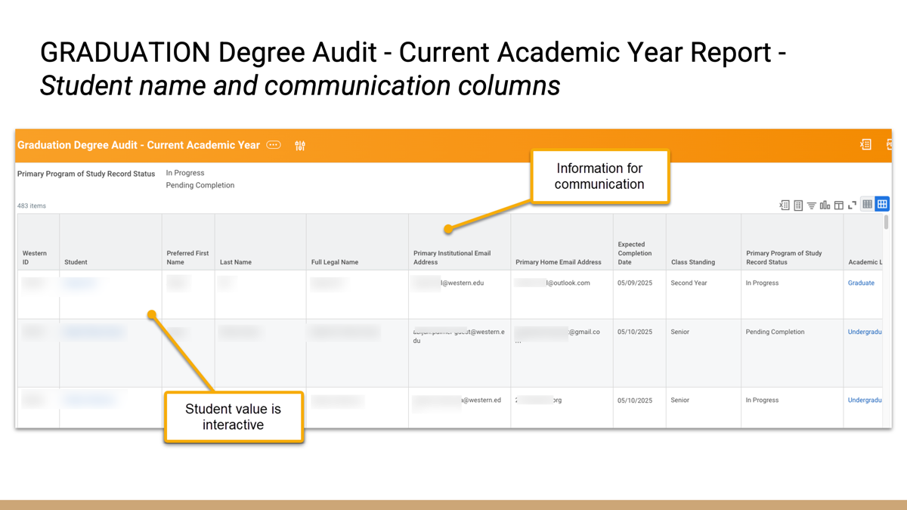
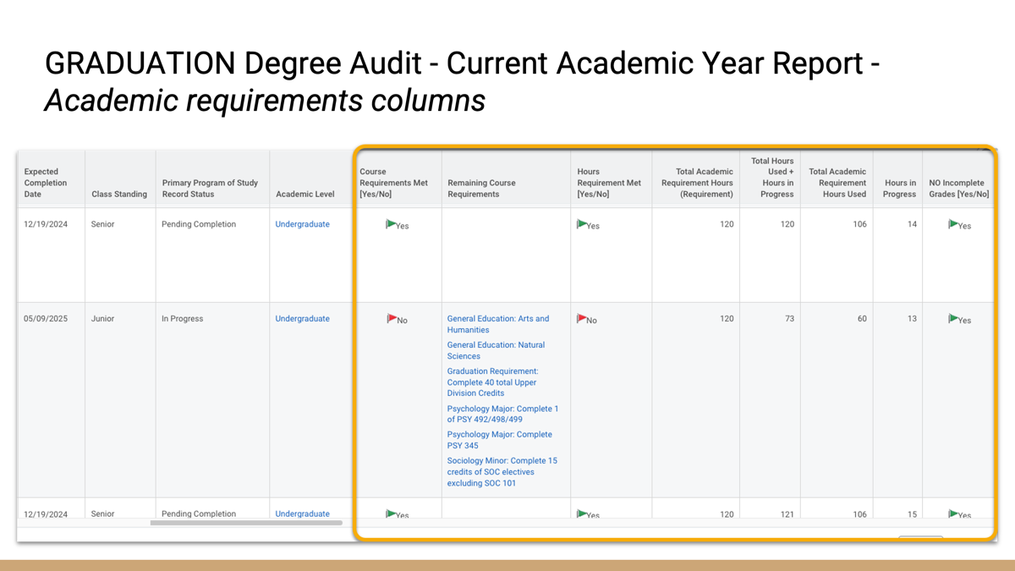

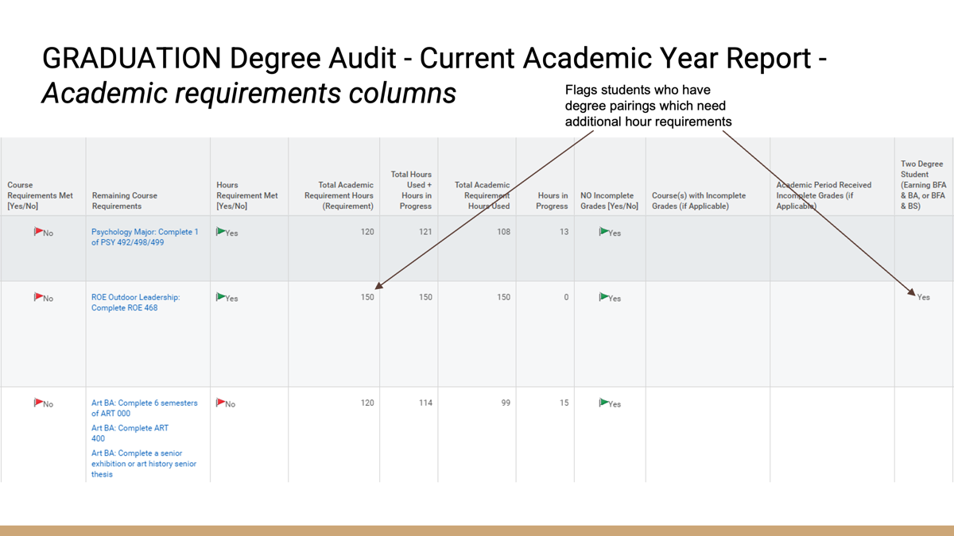

STEP 5: Complete Programs of Study
- At the end of the process, after final grades are posted, use the Program Completion EIB to officially complete records.

- This ensures accurate federal reporting and financial aid compliance.

- Pending Completion status can still be used very late in the process, such as graduation weekend, if the institution wants additional control.

BENEFITS OF THE COHORT APPROACH
- Flexibility to move students between cohorts as plans change
- Clear visibility into student graduation status
- Ability to capture detailed scenarios such as commencement attendance or outreach needed
- Accurate reporting through EIB-driven data
- Better staff experience by avoiding repeated edits to Programs of Study

